Instructions for using
Main parameters: Input voltage: AC AC: 180V ~ 260V
Output voltage: DC: 5KV ~ 60KV
Output current: 0~10mA
Positive and negative discharge distance should be less than 8cm

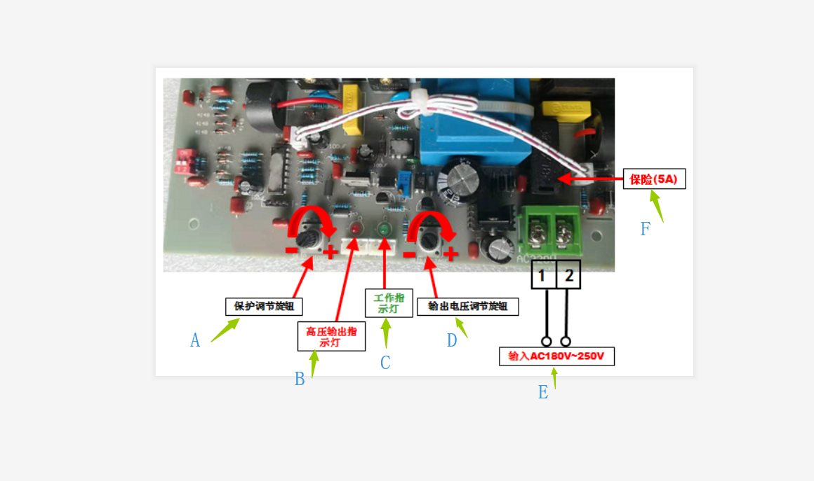
A： Protection adjustment knob
B: High voltage indicator output lamp
C: Work indicator
D: Output voltage adjustment knob
E: Input AC180V~250V
F: Insurance (5A)

Instructions:
1. Connect the high voltage output line to the required load. The red line is the high voltage output positive pole and the black line is the high voltage output negative pole. Please pay special attention to!!! The high voltage output line of the power supply must be connected to the load; the positive and negative discharge distances should be less than the specified Discharge distance (8cm), so as not to damage the power supply due to high voltage.
2. Turn off the protection circuit and protect the potentiometer from turning counterclockwise to the off position.
3. Connect 220V AC voltage, work indicator (green) and high voltage output indicator (red) light at the same time, and the power supply outputs high voltage; adjust the voltage adjustment potentiometer to select the required voltage; clockwise adjustment, output voltage rise High, counterclockwise adjustment, output voltage is reduced.
4. If the ignition protection function is required, please turn the protection adjustment potentiometer clockwise to the high-voltage output indicator (red) flashing state, and then turn counterclockwise until the red light is always on. At this time, the ignition protection function setting is completed ( During the adjustment process, be careful to rotate the potentiometer slowly, do not rotate too fast.) When there is a spark, short circuit or open circuit between the positive and negative electrodes, the power supply can be protected. When the power supply is protected, the working indicator light is always on, the high-voltage output indicator is off, and the high-voltage output is cut off. After 0.5-1 second delay, the power supply automatically restarts.
5. When the power supply has multiple open circuit protections, the power supply will automatically turn off the output and be in the locked state. At this time, the power supply no longer outputs high voltage, and the high voltage output indicator flashes, and the work indicator is off. After the power is turned off and then turned back on, the power returns to normal.
6. Short circuit protection and ignition protection will not cause the power supply to enter a locked state.

Precautions:
1. This high voltage internal backplane is charged. Please be careful!
2, the high-voltage output line must be away from the 220V input line, indicator wiring, the two can not be tied together or close to the cable!
3. The two high-voltage output lines cannot be bundled together and lined up together, otherwise it is easy to burn high-voltage lines.
4. The high-voltage line needs to use a wall-through porcelain tube or an insulating tube in the place where the hole is perforated.
5, high-voltage power supply should be away from high temperature and humidity environment, pay attention to ventilation!

